3.6

Film table does not look to have any duplicates

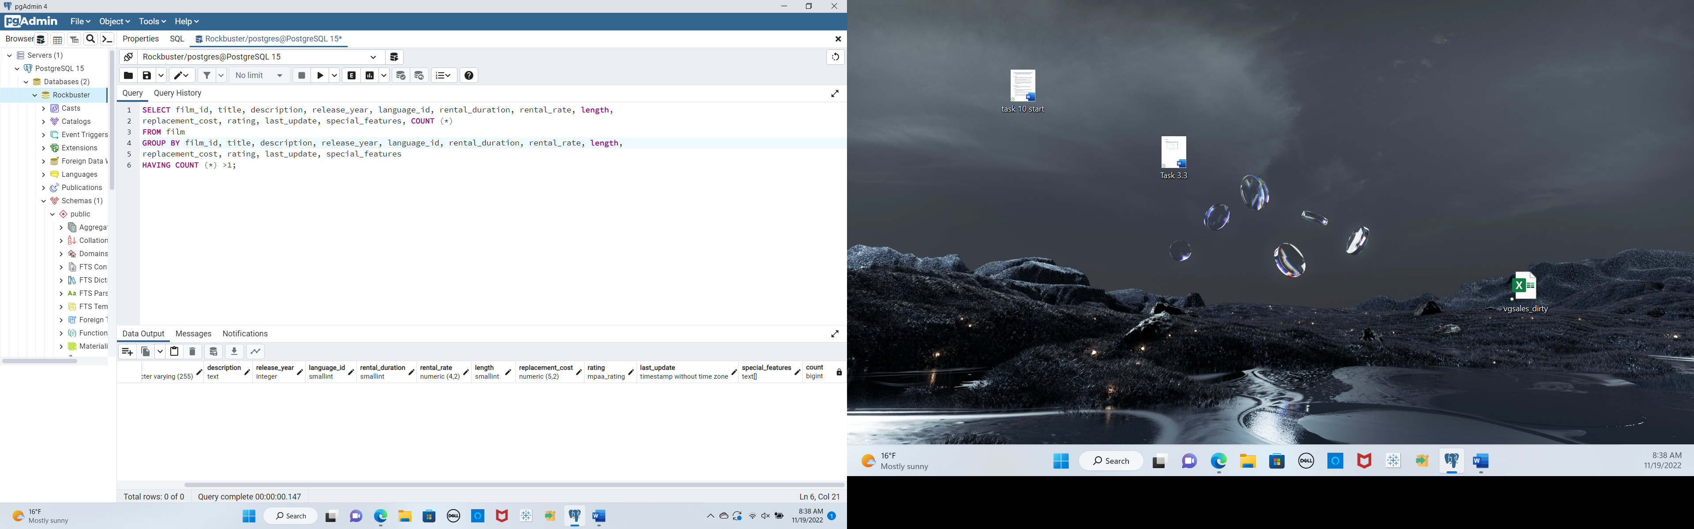

Customer table does not have any duplicates

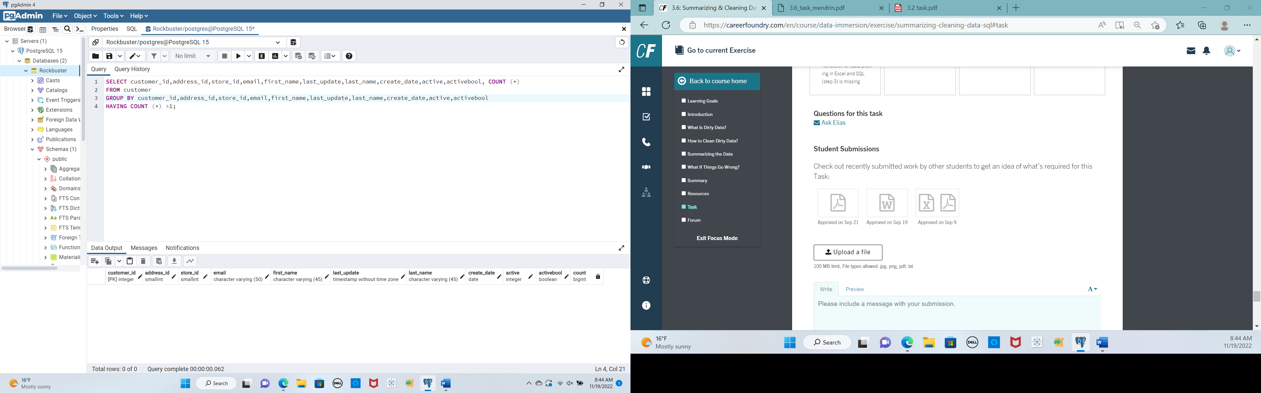

Non Uniform Data for film table

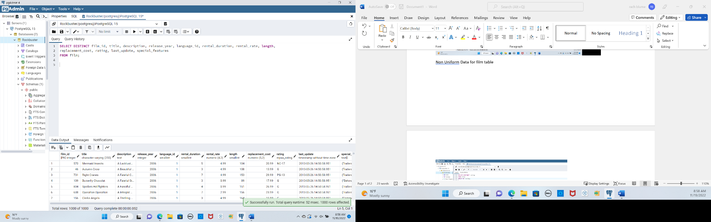

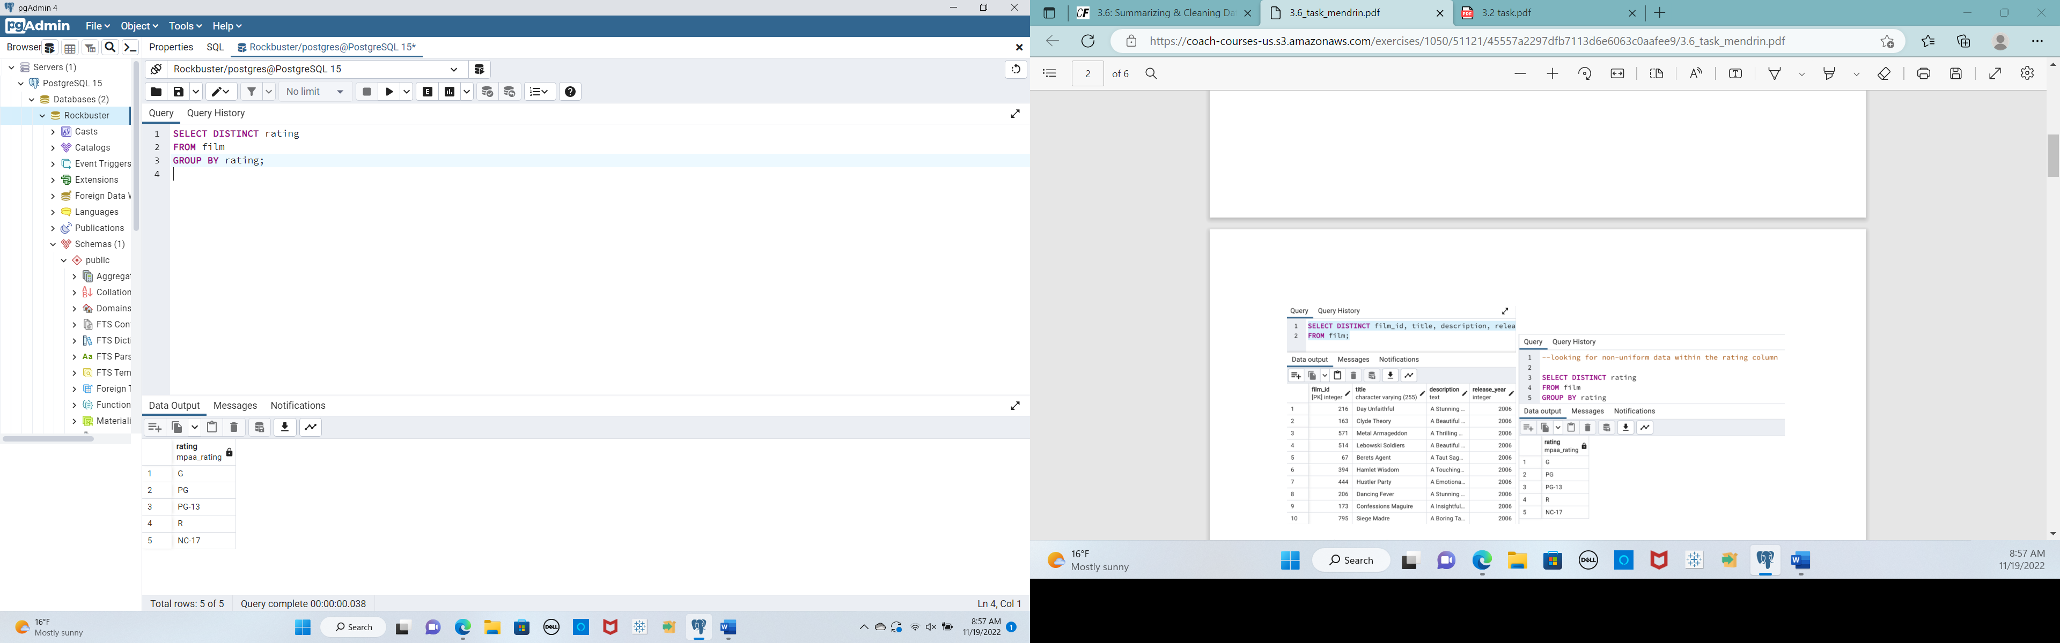

FROM CUSTOMER

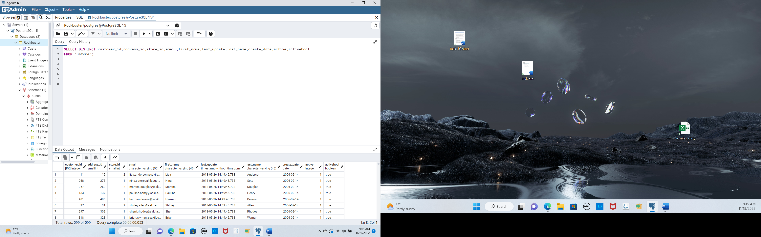

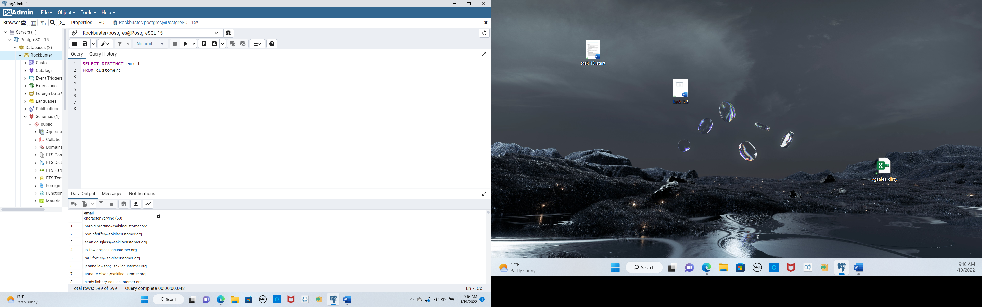

There were no duplicates in either table by doing the search. Utilizing the VIEW command where you can select only unique records also allows you to look and clean the tables. Normally using the VIEW as a virtual table allows us to use SELECT query and then it can be altered later on so that none of the data is altered for safety. You can also GROUP or use DISTINCT to find unique records. DINSTINCT searched both tables for a specific result. If you wanted to make the data uniform then you could write an update query such as the example they gave: UPDATE film SET RATING= ‘G’ WHERE rating IN (‘gen’, ‘g’, ‘General’) this would update all the various G ratings to look the same .

It is best to ignore columns with lots of missing data – that is why I ran the email query. If there are only a few missing values then you could try to replace it with maybe a generic but columns with too many missing values need to be ignored.

( SELECT column 1,column2,column5

–column 4 ignored in select because of missing values

FROM tablename)

2. FILM TABLE STATS

SELECT

MIN (film_id) AS min_film_id,

MAX (film_id) AS max_film_id,

AVG (film_id) AS avg_film_id,

MIN (release_year) AS min_release_year,

MAX (release_year) AS max_release_year,

AVG (release_year) AS avg_release_year,

MIN (language_id) AS min_language_id,

MAX (language_id) AS max_language_id,

AVG (language_id) AS avg_language_id,

MIN (rental_duration) AS min_rental_duration,

MAX (rental_duration) AS max_rental_duration,

AVG (rental_duration) AS avg_rental_duration,

MIN (rental_rate) AS min_rental_rate,

MAX (rental_rate) AS max_rental_rate,

AVG (rental_rate) AS avg_rental_rate,

MIN (length) AS min_length,

MAX (length) AS max_length,

AVG (length) AS avg_length,

MIN (replacement_cost) AS min_replacement_cost,

MAX (replacement_cost) AS max_replacement_cost,

AVG (replacement_cost) AS avg_replacement_cost,

MODE () WITHIN GROUP (ORDER BY title) AS mode_title,

MODE () WITHIN GROUP (ORDER BY description) AS mode_description,

MODE () WITHIN GROUP (ORDER BY rating) AS mode_rating,

MODE () WITHIN GROUP (ORDER BY special_features) AS mode_special_features,

MODE () WITHIN GROUP (ORDER BY fulltext) AS mode_fulltext

FROM film;

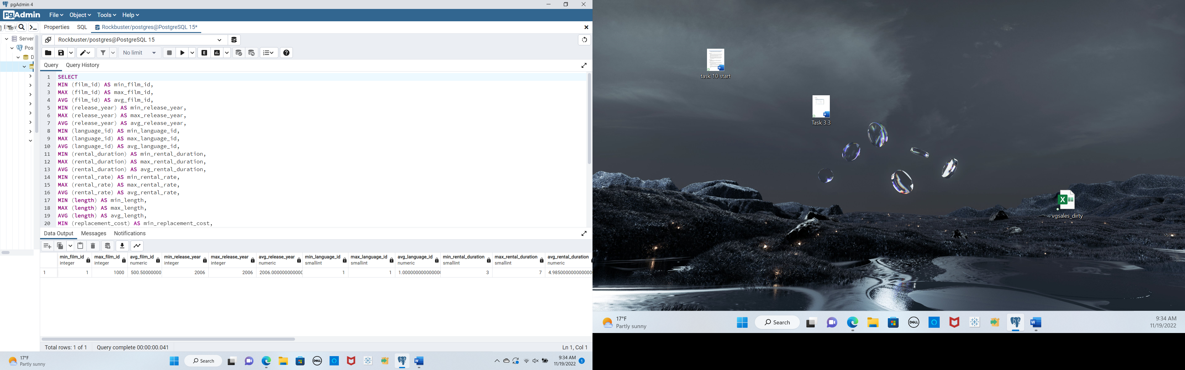

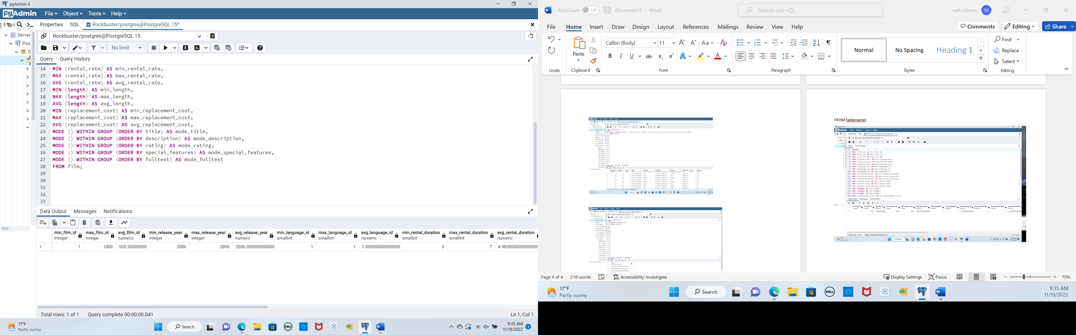

SELECT

MIN (customer_id) AS min_customer_id,

MAX (customer_id) AS max_customer_id,

AVG (customer_id) AS avg_customer_id,

MIN (store_id) AS min_store_id,

MAX (store_id) AS max_store_id,

AVG (store_id) AS avg_store_id,

MIN (address_id) AS min_address_id,

MAX (address_id) AS max_address_id,

AVG (address_id) AS avg_address_id,

MIN (active) AS min_active,

MAX (active) AS max_active,

AVG (active) AS avg_active,

MODE () WITHIN GROUP (ORDER BY first_name) AS mode_first_name,

MODE()WITHIN GROUP (ORDER BY last_name) AS mode_last_name,

MODE () WITHIN GROUP (ORDER BY email) AS mode_email,

MODE ()WITHIN GROUP (ORDER BY active) AS mode_active,

MODE ()WITHIN GROUP (ORDER BY activebool) AS mode_activebool

FROM customer;

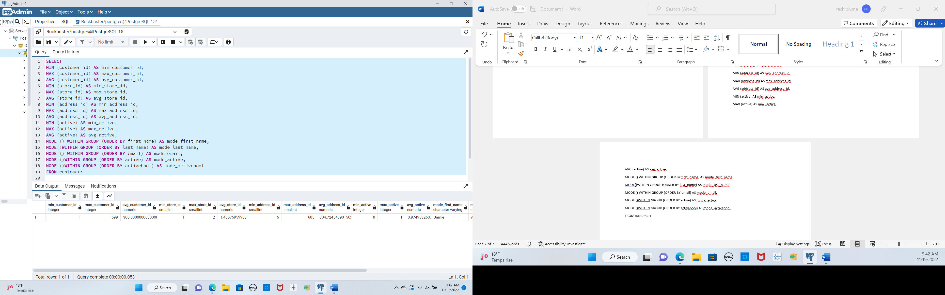

3. I wish we would have used SQL to help clean the data we used in our last achievement. I think back to the CDC data and all of the things that I was manually sorting or looking for anomalies where this is a cleaner way to find duplicates and other non-uniform data. I think Excel has its place but I feel this is a quicker way to clean things. It seems that SQL has a few prompts that can be easily implemented to query quick results. IT may take a little longer as I learn to write queries but I think overall it is a good option to use SQL going forward.